eMOLT
Fall 2005
Update

These are brief notes to keep you informed of what's happening with eMOLT (Environmental Monitors on Lobster Traps). While I occasionally submit a page of news to your local association newsletter, my intention here is to provide you, the participants, with a little more detail on the results to date.

Temperature Record Analysis:
Now finishing up our fifth year with bottom temperature probes at dozens of locations around the Gulf of Maine and Southern New England shelfedge, we can actually begin to conclude a few things. We can say more than “It has been unusually cold lately”. We can say things like, “The temperature has been X standard deviations less than the mean, Y”. The values “X” and “Y” vary by location and time, of course. We need at least a few years to conduct these basic statistics. So, let’s take David Johnson's site, for example, where he has had a probe in the same location and depth for most of the year since 2001 (Figure1). For each day of the year we can start to calculate averages and typical deviations about that average. The “anomalies” are plotted in Figure 2 for the case of several participants. 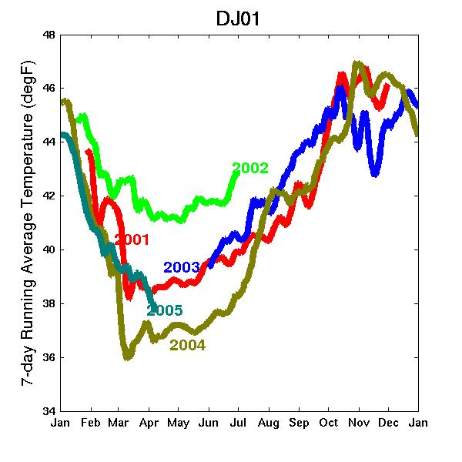
Figure 1. Multi-year temperature record example.
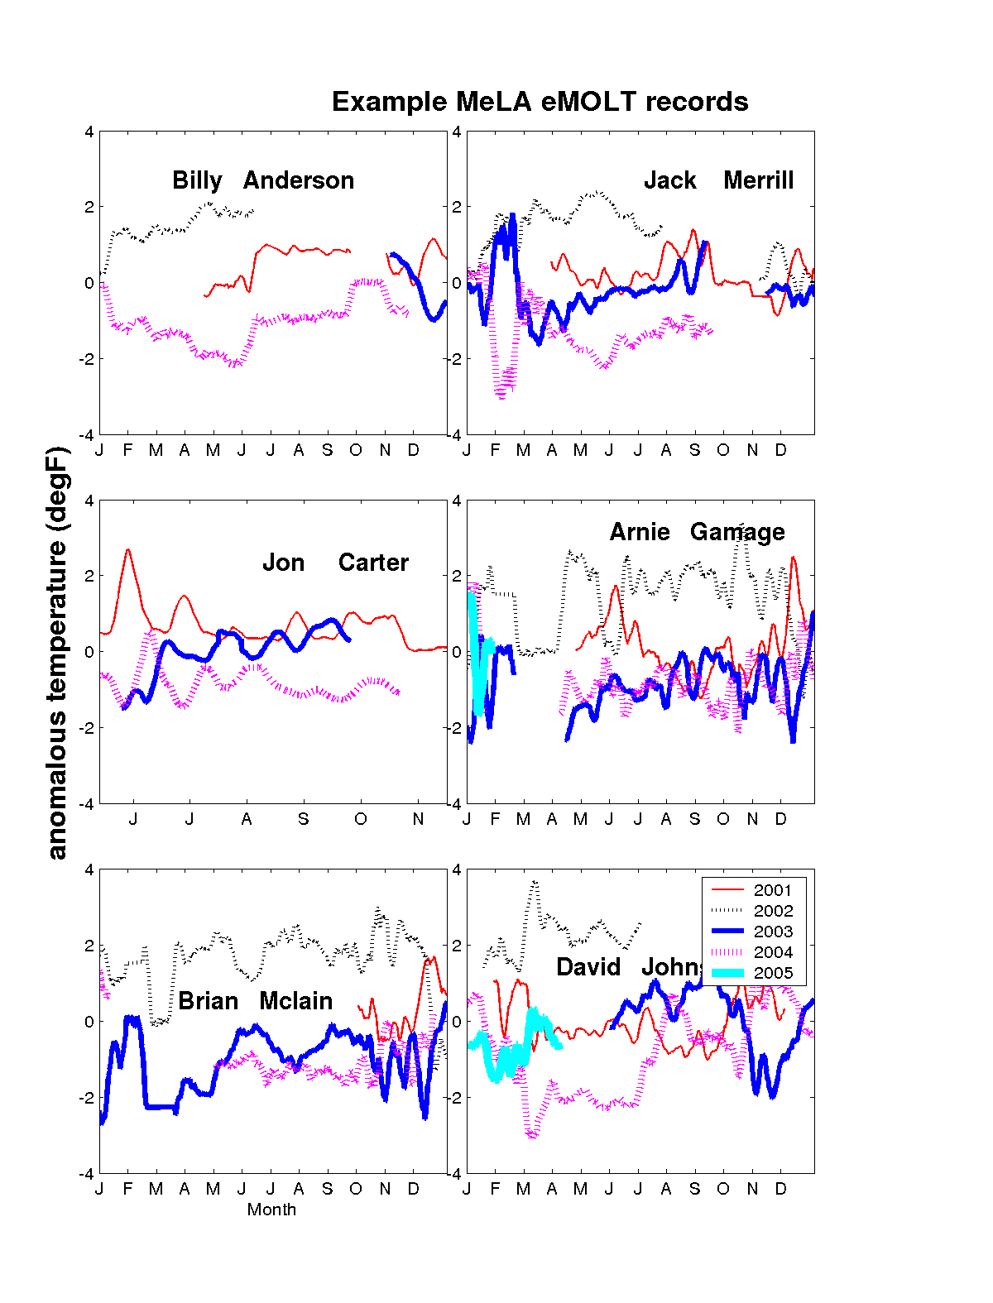
Figure 2. Anomalous temperature records

Realtime temperature sensors:
As many of you are aware, we are working on developing a sensor to report “realtime” bottom temperature so you do not have to wait for nearly a year before you see your records. We hope to have a unit available to demo at the 2006 forums.

Catch vs Temperature Analysis:
In the past, several participants have submitted records of their catch along with their temperature probe documentation. In these cases, we have worked up the data and provided these individuals with plots of the results overlaid on temperature. Being a physical oceanographer (not a biologist), I do not try to interpret the relationship. We will continue to provide this type of basic analysis for any participants submitting their catch records in electronic form.

Drifter Results from 2005:
Another component of the eMOLT project is observations of current. The students at Southern Maine Community College continue to make drifters for the eMOLT project and, in fact, are making them for other research projects as well now. These drifters, each fitted with GPS units, are used to track/simulate lobster larvae transport along the coast as well as many other planktonic organisms such as harmful algal blooms. The Gulf of Maine Lobster Foundation has taken on the administrative duties in contracting the students and supplying a number of research institutions with this instrumentation. The main purpose of these drifters is to validate the numerical circulation models currently underdevelopment at various New England universities (more on these numerical model results in the next newsletter).

Both in 2004 and 2005, drifters were deployed by lobstermen. To see the full story of each drifter deployed, visit the “Drifter Study” link under www.emolt.org. Shown in Figure 3 below is the result of all the 2005 drifter tracks.

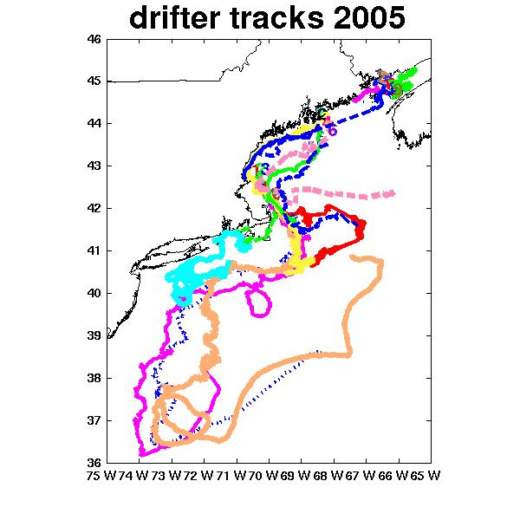
Figure 3. Drifter Tracks 2005
You can see that some deployments were made in the Bay of Fundy, off mid-coast Maine, off Cape Ann, and off Truro, Ma. Figure 4 (below) has the details Billy Souza's deployment off Truro. It was caught in the Gulf Stream in early October.
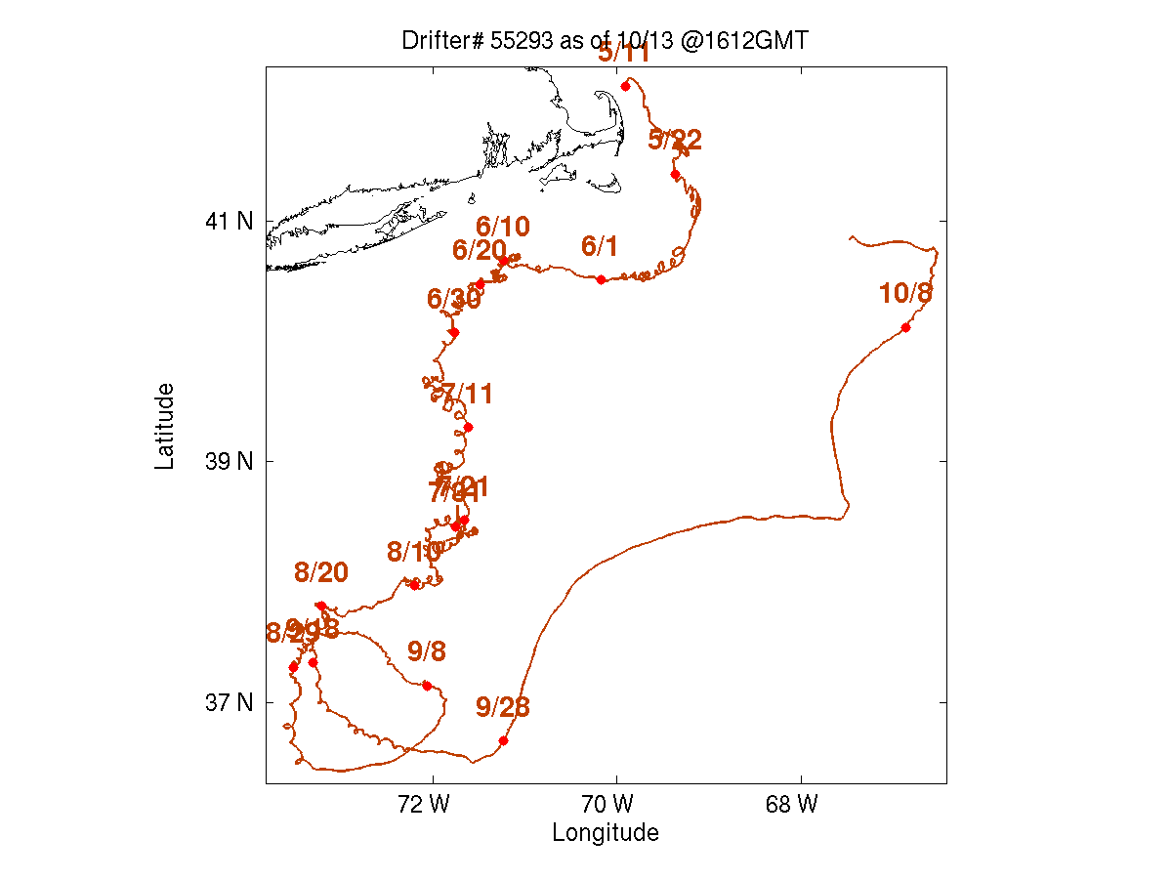
Figure 4. Billy Souza-deployed drifter track May-Oct 2005.

Reminders
Keep in mind that we will be collecting temperature probes during the month of December and will be returning probes to you by March. Those wishing to keep probes in for the winter months are encouraged to do so. Just let us know if this is the case and we will send you a replacement probe to switch out.

If you have any questions about eMOLT, call 508-495-2211, email james.manning@noaa.gov or contact your association representative.

